CONCEPT NOTE

Kigali Knowledge Crossroads
EDUCATION IN MOTION. RESEARCH IN ACTION
October 2027

Kigali Knowledge Crossroads Week (October 2027)
Kigali Knowledge Crossroads Week (October 2027) will be built around the GCUB General Assembly, an international conference, thematic workshops, and a collective plan of action. Its workshops are structured around a continuous knowledge cycle—from vision and plural knowledge systems to learning, innovation, and societal solutions—ensuring that knowledge remains in motion and responsive to real-world challenges.

Background
As part of its annual General Assembly, GCUB and its member institutions will gather in Kigali in October 2027, bringing together university leaders and partners from across the Global South and beyond. In parallel, GPS will convene Kigali Knowledge Crossroads Week, its flagship global gathering. This convening will bring together universities, policymakers, public institutions, entrepreneurs, artists, and civil society actors from five continents.
The Week is intentionally designed not as a traditional academic conference, but as an action-oriented platform where:
- research informs policy
- education responds to societal needs
- ideas become actionable solutions
- partnerships generate measurable social and economic impact

Rationale
At a time when education systems, labor markets, emerging technologies—especially artificial intelligence—and global power relations are being reshaped, Kigali Knowledge Crossroads responds to the urgent need to realign learning, research, and public action.
Across the Global South, universities produce critical knowledge in education, public health, digital transformation, climate resilience, governance, and entrepreneurship. Yet too often this knowledge remains confined within academic spaces, disconnected from policymaking, economic transformation, and everyday realities.
At the same time:
- governments seek evidence-based and context-sensitive policies
- education systems must rethink curricula, pedagogies, and methodologies
- the private sector requires research-informed innovation and graduates aligned with real-world needs
Education must be in motion: responsive to lived realities, grounded in local and global knowledge, and equipped with adaptive curricula and methodologies. Research must be in action: translated into policy, entrepreneurship, and social impact. Knowledge, therefore, should function as a social contract linking universities to society, connecting research to decision-making, and aligning education with community aspirations.

Vision
Kigali Knowledge Crossroads Week is conceived as a catalytic moment defined by its integrative and cyclical architecture—bringing together universities, governments, and innovators within a sustained transcontinental process where knowledge is co-produced, shared, and mobilized for social and human development.
It advances an approach to knowledge that is context-responsive, historically grounded, and socially embedded—engaging lived experience while contributing to global conversations on development, governance, and innovation. Strategically, the Crossroads operates as a collaborative platform where universities, public institutions, and enterprises co-design practical and scalable solutions for sustainable development across the Global South.

Objectives
The Week aims to:
- Advance educational reconfiguration through curriculum innovation and adaptive pedagogies
- Strengthen dialogue between universities and public institutions for evidence-based policymaking
- Catalyze university–industry collaboration for entrepreneurship and innovation ecosystems
- Deepen South–South cooperation while reinforcing strategic South–North collaboration
- Convert research into implementation through pilot projects and scalable initiatives
- Expand academic mobility, joint programming, and collaborative research platforms
- Institutionalize research–policy interfaces that support diplomacy and international cooperation

Nature of the Event
The Week integrates three complementary components:
1. GCUB General Assembly
A strategic forum for presidents, rectors, and institutional leaders focused on governance, planning, mobility, and international cooperation.
2. Multisectoral International Conference
A platform for researchers, private-sector actors, Indigenous knowledge holders, policymakers, and artists. Academic papers will be selected through peer review, while other contributions will be curated through an expert-led process.
3. Kigali Knowledge Crossroads Platform
A broader academic-policy-societal forum featuring:
- thematic panels and workshops
- policy dialogues and university-government roundtables
- education reform sessions
- entrepreneurship and innovation forums
- partnership meetings and MoU signings
- youth and early-career engagement
- exhibitions and cultural programming

Expected Outputs
- policy briefs and advisory notes
- partnership agreements and MoUs
- joint programs and mobility schemes
- pilot projects and innovation initiatives
- collaborative research agendas

Scale and Participants
The forum will convene approximately 400–500 participants from five continents, including university leaders, researchers, students, government representatives, diplomats, entrepreneurs, civil society leaders, artists, innovators, and development partners. This diversity ensures that knowledge producers, decision-makers, and societal actors collaborate to co-design and implement partnerships.

Strategic Pillars and Thematic Tracks
From Knowledge → Education & Methods → Policy → Partnerships → Impact
The thematic architecture includes:
- Pedagogy and Curriculum Development
- Technology and Digital Innovation
- Epistemology and Knowledge Systems
- Applied and Impactful Teaching & Research
- Research Funding and Resource Mobilization

- Track I: Pedagogy and Curriculum Development
(Addressing teaching methods, learning approaches, and evolving content needs)
- Track II: Technology and Digital Innovation
(Integrating digital tools, platforms, and emerging technologies in education and research)
- Track III: Epistemology and Knowledge Systems
(Exploring how knowledge is produced, validated, and contextualized across disciplines and regions)
- Track IV: Applied, Impactful Teaching and Research
(Promoting practice-oriented learning and research with tangible societal impact)
- Track V: Research Funding and Resource Mobilization
(Strengthening sustainable financing, partnerships, and support mechanisms for research)

This architecture positions the initiative as a transformative platform for advancing a new paradigm of knowledge, structured around five interconnected pillars—from knowledge production to education and methods, from policy engagement to partnerships, and ultimately to measurable societal impact. It articulates a holistic vision in which universities are not only centers of knowledge, but active agents of societal transformation, fully aligned with human progress, lived realities, and global challenges:
• Pedagogy and Curriculum Development
(Addressing teaching methods, learning approaches, and evolving content needs)
• Technology and Digital Innovation
(Integrating digital tools, platforms, and emerging technologies in education and research)
• Epistemology and Knowledge Systems
(Exploring how knowledge is produced, validated, and contextualized across disciplines and regions)
• Applied, Impactful Teaching and Research
(Promoting practice-oriented learning and research with tangible societal impact)
• Research Funding and Resource Mobilization
(Strengthening sustainable financing, partnerships, and support mechanisms for research)

Pillar I. Pedagogy and Curriculum Development

Transforming Education for Lived Realities and Future Societies
Core idea:
Education must move beyond the transmission of abstract knowledge to prepare learners to engage with real-world challenges, contribute to society, and shape the future.
Strategic purpose:
To reorient education toward experiential learning, critical thinking, innovation, and societal relevance—ensuring that graduates are equipped to address complex social, economic, technological, and environmental challenges.
Associated themes:
- Education in Motion: Curricula and Pedagogies for Lived Realities
Reimagining teaching and learning to connect education with lived experience and real-world problem-solving.
- Youth, Entrepreneurship, and Innovation
Empowering students and young graduates as innovators, entrepreneurs, and leaders of societal transformation.

Pillar II. Technology and Digital Innovation

Reconfiguring Knowledge Ecosystems in the Digital Age
Core idea:
Digital technologies are not merely tools—they are reshaping how knowledge is produced, shared, and applied.
Strategic purpose:
To integrate digital transformation, artificial intelligence, and emerging technologies into education and research systems in ways that are inclusive, ethical, and socially responsive.
Associated themes:
3. Digital Transformation, AI, and Innovation
Examining how emerging technologies are transforming education, research, and knowledge ecosystems.
4.Technology for Inclusion and Access
Leveraging digital tools to expand access to education and reduce structural inequalities.

Pillar III. Epistemology and Knowledge Systems

Plural Knowledge Systems: Indigenous, Endogenous, and Global Epistemologies
Core idea:
The future of global knowledge depends on recognizing, valuing, and integrating diverse knowledge systems alongside scientific and academic traditions.
Strategic purpose:
To advance epistemic pluralism, strengthen context-grounded knowledge systems, and promote more inclusive and balanced global knowledge architectures.
Associated themes:
5. Epistemologies of the South: Rebalancing Global Knowledge Systems
Advancing recognition of diverse epistemological traditions and fostering more equitable global knowledge systems.
- Indigenous and Endogenous Knowledge Systems
Exploring how locally rooted knowledge contributes to innovation, resilience, sustainability, and development.

Pillar IV. Applied, Impactful Teaching and Research

Advancing Research for Societal Challenges and Human Progress
Core idea:
Research and teaching must generate actionable knowledge that directly contributes to solving societal challenges.
Strategic purpose:
To align research priorities and pedagogical practices with real-world needs, fostering interdisciplinary and transdisciplinary approaches that produce tangible impact.
Associated themes:
7. Science, Research, and Societal Challenges
Mobilizing research to address pressing global issues such as health, climate, energy, and sustainable development.
- Social Sciences and Humanities in Action
Leveraging humanities and social sciences to support inclusive, ethical, and sustainable transformation.
- Transdisciplinary Innovation Labs
Converging knowledge across disciplines and sectors to generate integrated, actionable solutions.
- Measuring Social Impact
Developing frameworks to assess how education and research contribute to societal well-being and transformation.

Pillar V. Research Funding and Resource Mobilization

Knowledge Partnerships: Connecting Universities, Policy, and Society
Core idea:
Sustainable impact requires strategic partnerships and robust resource mobilization to support knowledge ecosystems.
Strategic purpose:
To strengthen collaboration among universities, policymakers, funders, civil society, and global partners, ensuring that knowledge is translated into policy, innovation, and long-term societal benefit.
Associated themes:
11. Research-Informed Public Decisions
Strengthening mechanisms that connect research with policymaking and governance.
- Knowledge Partnerships for Societal Impact
Building cross-sector and cross-regional collaborations to co-produce knowledge and drive transformation.
- Sustainable Funding and Resource Mobilization
Developing innovative financing models and institutional partnerships to support research, education, and innovation ecosystems.
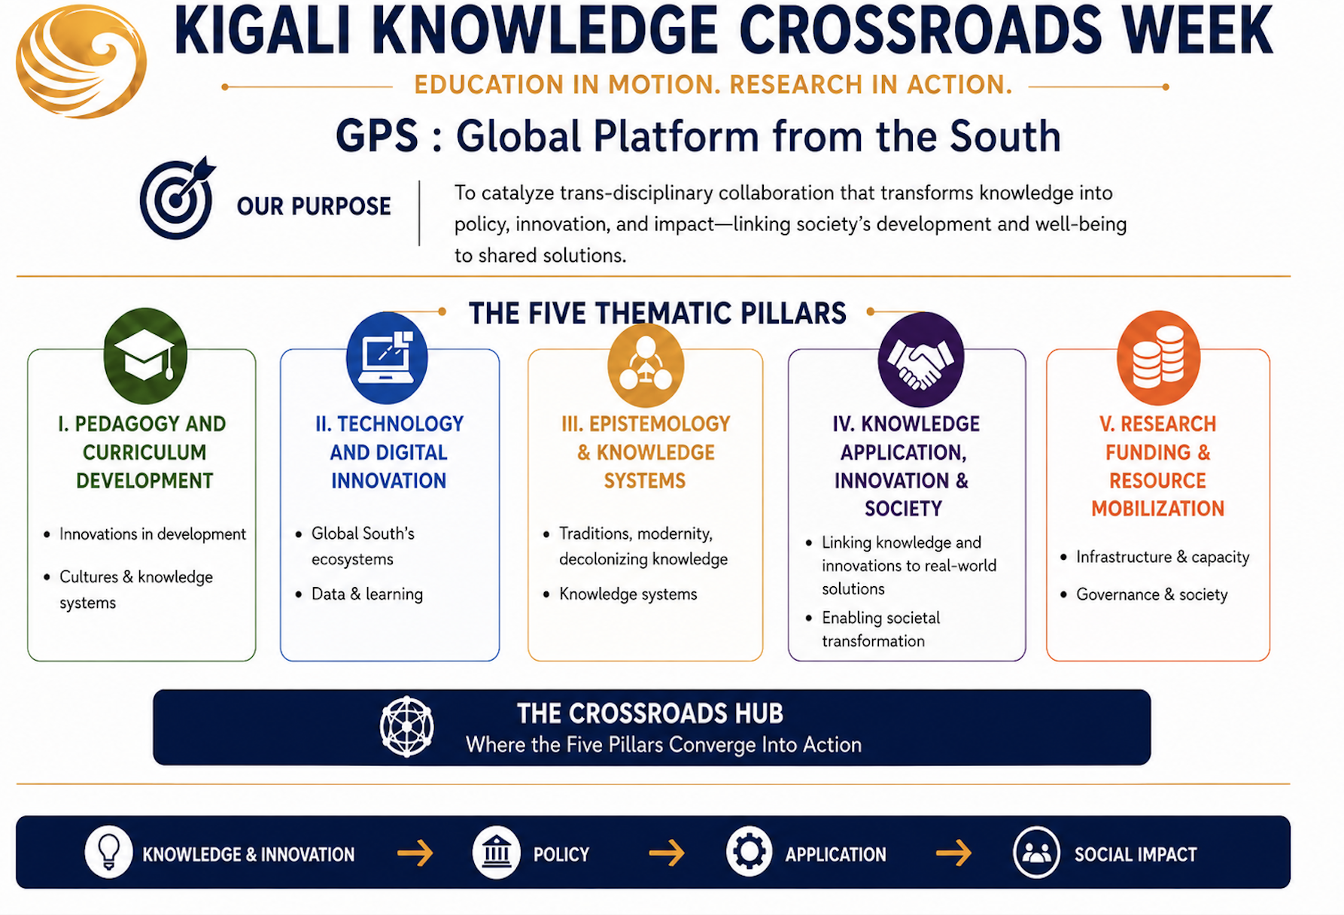

Together, these five pillars operationalize as continuum of transformation:
From Knowledge → to Education & Methods → to Policy → to Partnerships → to Impact
They position the initiative not as a conventional academic gathering, but as a living platform for co-creation, where:
- knowledge is produced across diverse epistemologies,
- education is reimagined for lived realities,
- research is mobilized for societal challenges,
- partnerships are activated across sectors and regions, and
- impact is measured in human, institutional, and societal transformation.
This integrated architecture reflects a new contract between universities and society—one grounded in relevance, responsibility, and the co-production of knowledge for a more just, inclusive, and sustainable world.

Strategic Implementation Outcomes
Knowledge in Action Week is designed to generate concrete, measurable, and durable outcomes that extend well beyond the event itself. The Week will serve as a launchpad for year-long and multi-year collaborations facilitated by the Africana Bridging Center in partnership with participating institutions.

1.Academic Mobility and Access
MoUs, joint supervision models, tuition cooperation, and pilot mobility schemes in priority disciplines.

2. Joint Research and Knowledge Production
Thematic research consortia, collaborative projects, co-authored publications, and applied research outputs.

3. Curriculum and Pedagogical Innovation
Co-developed curricula aligned with societal needs, experiential learning models, and shared pilot programs.

4. Policy Engagement and Decision Support
Policy briefs, structured university–government dialogue, and research-to-policy pathways.

5.University–Industry and Innovation Partnerships
Innovation platforms, startup support, incubation initiatives, and investment-ready research projects.
6.Coordination, Evaluation, and Impact
Ongoing coordination support and voluntary progress-sharing moments, with additional agreements and collaborations emerging after the Kigali Week, facilitated by the Africana Bridging Center.
ABOUT US
The Global Platform for the South (GPS) is a transdisciplinary ecosystem and convening platform dedicated to advancing inclusive development, innovation, and social transformation across the Global South. Headquartered in Kigali, with regional hubs in Addis Ababa, Dakar, and São Paulo, GPS connects institutions, decision-makers, practitioners, and collaborative networks to generate context-responsive solutions to shared challenges. Over the next two years, the platform aims to establish a presence in every major region of the Global South and the Global North through strategic partnerships, hubs, and affiliated universities, institutes, and centers.
GPS serves as a bridge between ideas and implementation, transforming vision into research, research into knowledge, knowledge into policy and partnerships, and partnerships into action that generates results, improves lives, and strengthens societies. It advances sustainable and locally grounded progress through collaboration across education, innovation, entrepreneurship, and community leadership.
It is designed as a platform where the South not only participates in global conversations, but also helps co-shape them.
The name GPS reflects both direction and impact.
- Direction: Just as a global positioning system helps people locate themselves and navigate complex terrains, GPS enables actors across the Global South to identify opportunities, align priorities, and chart pathways toward shared futures. It represents clarity of purpose, strategic coordination, and meaningful connection across regions.
- Impact: GPS is equally committed to ensuring that ideas lead to action and that knowledge produces measurable change. The platform is built to transform vision into research, research into knowledge, knowledge into policy and partnerships, and partnerships into action that generates results, improves lives, and strengthens societies.
Our guiding framework: KPI — Knowledge, Policy, and Impact.
KPI expresses the operating philosophy of the platform: that knowledge must inform policy, and policy must generate local and real-world impact. It reflects a commitment to evidence-based decision-making, practical collaboration, and continuous transformation across education, governance, innovation, and community development.

